**Practical 3: Build Your Virtual Private Cloud (VPC) and Launch a Web Server**

**Solution:**

Step 1: In the search box to the right of **Services**, search for and choose **VPC** to open the VPC console.

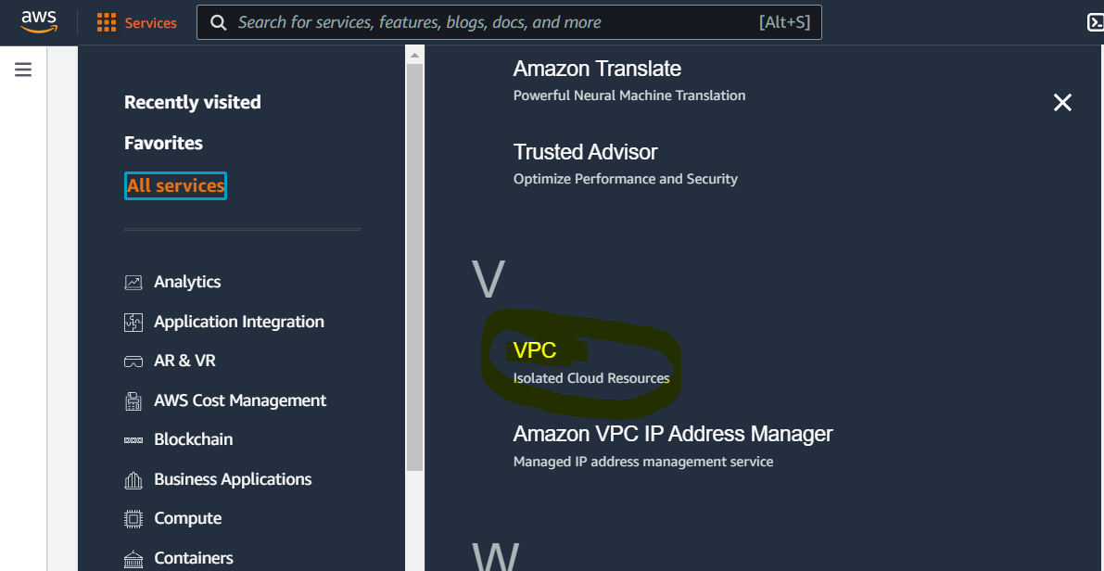

Note: If the status in the Health column is not Green, it has not finished starting yet. Wait a

few moments, and it should change to Green.

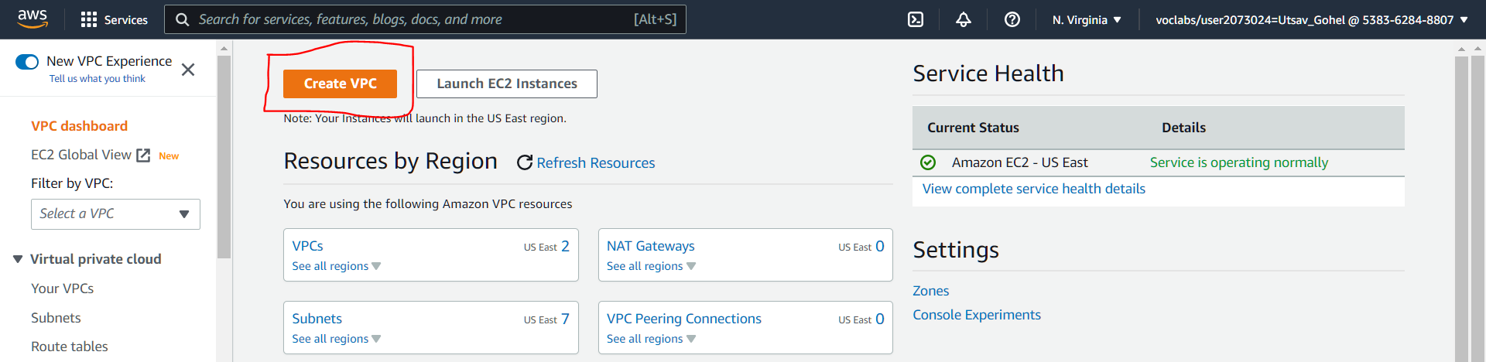

Configure the VPC details in the VPC settings panel on the left:

Choose VPC and more.

Under Name tag auto-generation, keep Auto-generate selected, however change the value from project to lab.

Keep the IPv4 CIDR block set to 10.0.0.0/16

For Number of Availability Zones, choose 1.

For Number of public subnets, keep the 1 setting.

For Number of private subnets, keep the 1 setting.

Expand the Customize subnets CIDR blocks section

Change Public subnet CIDR block in us-east-1a to 10.0.0.0/24

Change Private subnet CIDR block in us-east-1a to 10.0.1.0/24

Set NAT gateways to In 1 AZ.

Set VPC endpoints to None.

Keep both DNS hostnames and DNS resolution enabled.

Step 2: Under the **Environment name** column, choose the name of the environment.

The **Dashboard** page for your Elastic Beanstalk environment opens.

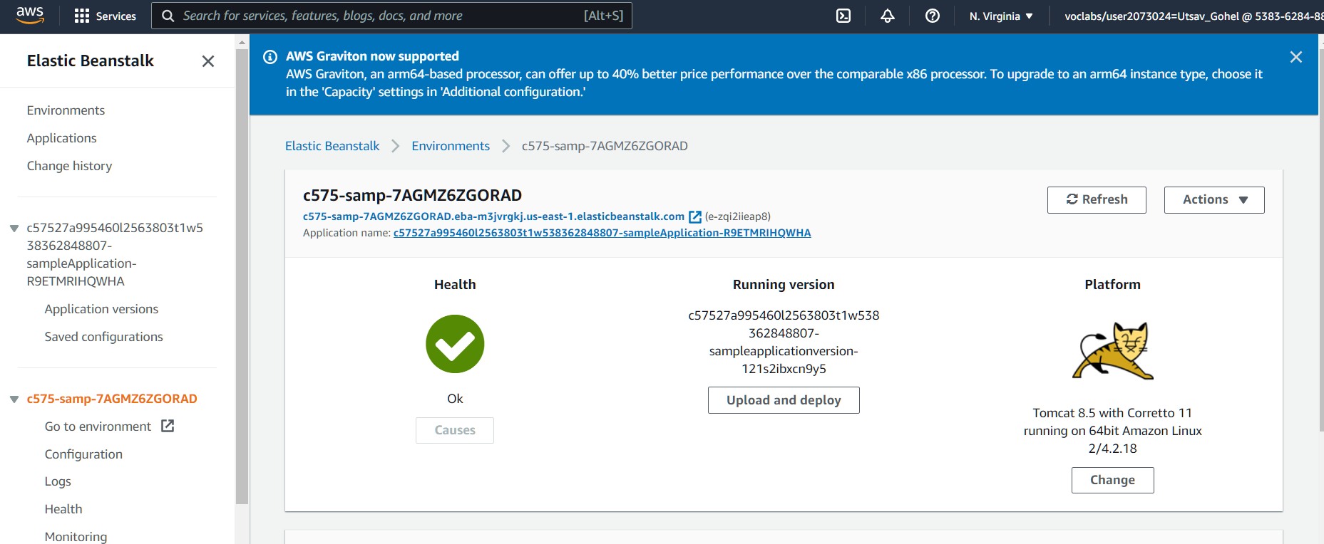

Step 3: Download sample file from given link and upload to running version center one as shown in figure

<https://docs.aws.amazon.com/elasticbeanstalk/latest/dg/samples/tomcat.zip>

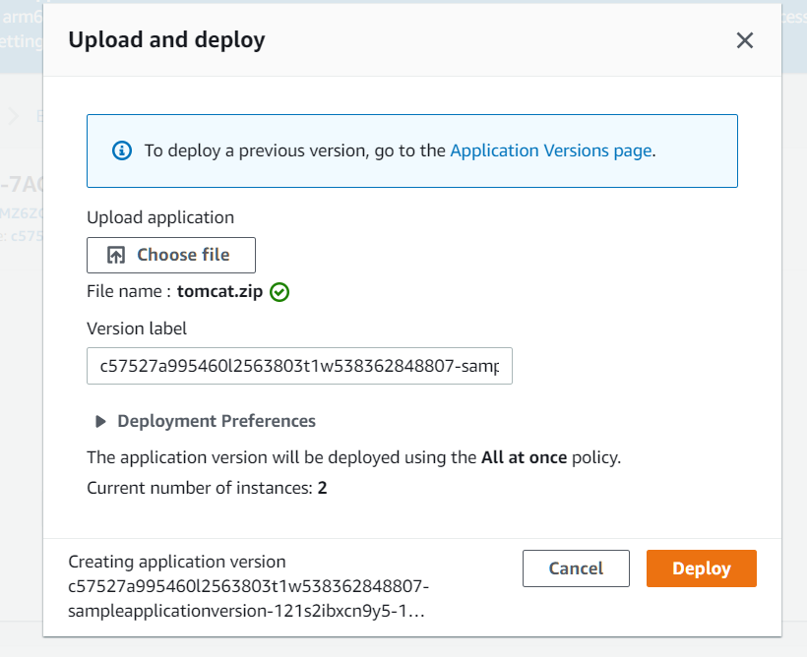

Step 4: Just copy the link of website and search in browser

<http://c575-samp-7agmz6zgorad.eba-m3jvrgkj.us-east-1.elasticbeanstalk.com/>

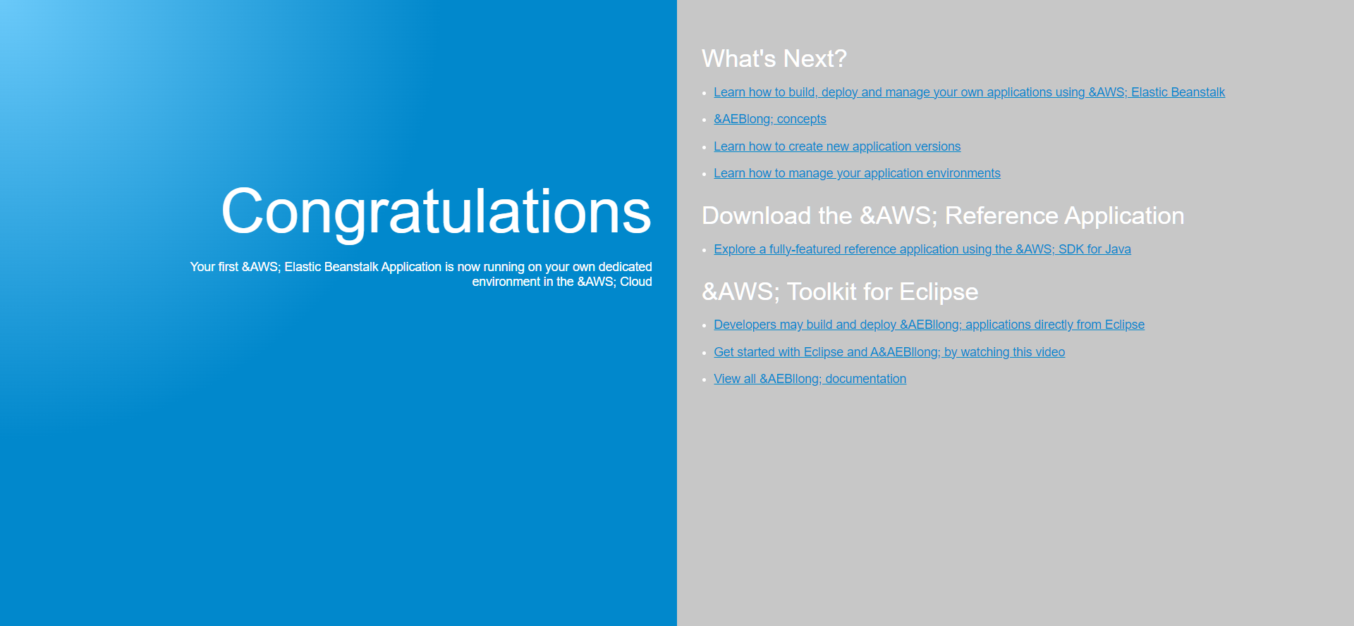

Thus your Website is Deployed on AWS